Library Book Management System- Validation Testing

This document contains the validation test for the Library Book Management System to ensure its functionality and reliability.

Below are Screenshots showing the testing process and result:

1. Login Screen

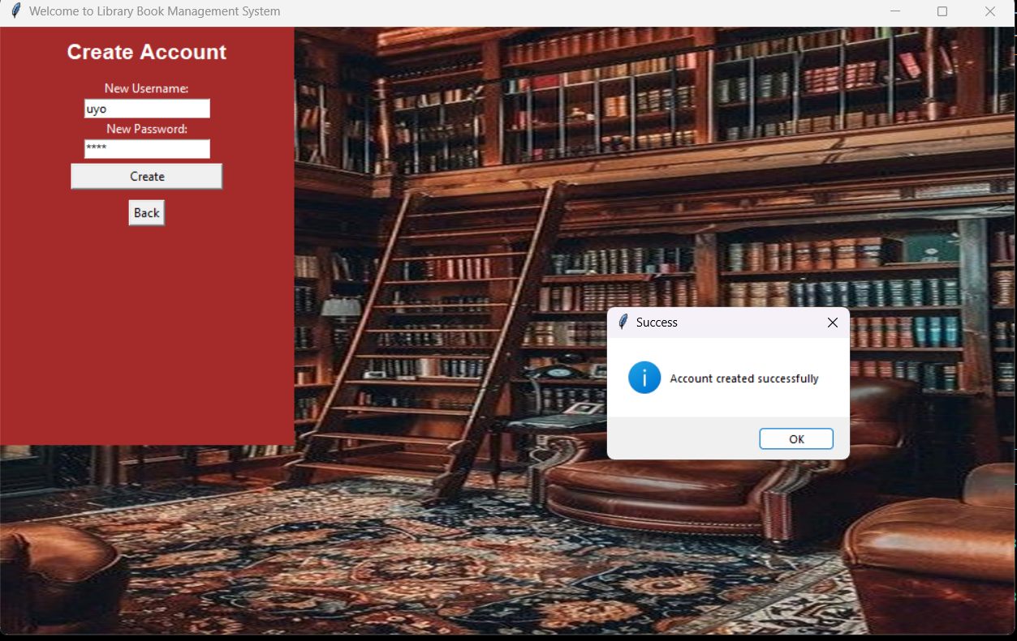

1. Dashboard

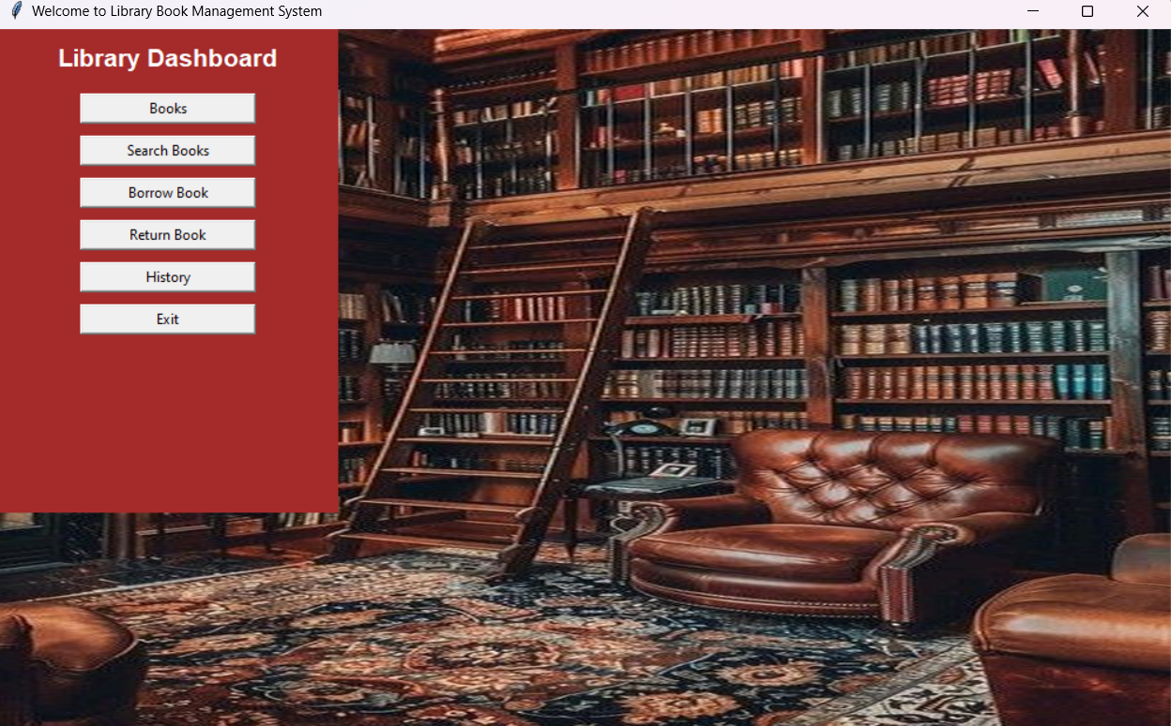

1. Books Available

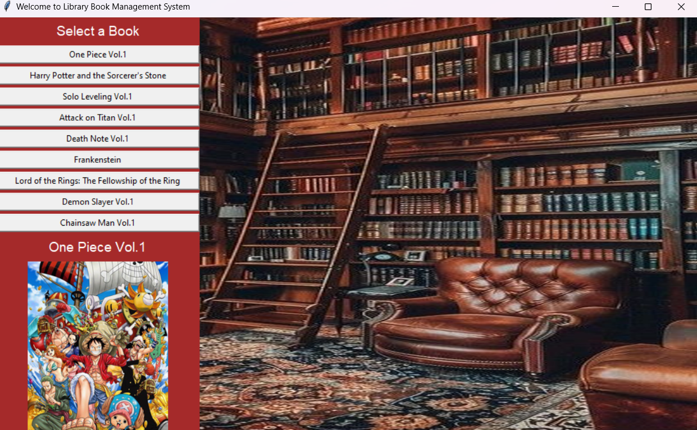

1. Search Books: You can search books by genre, title, or author.

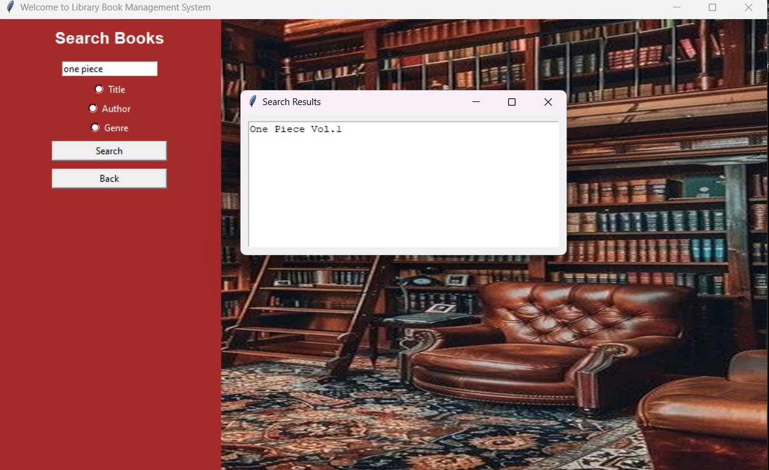

1. Borrow Book

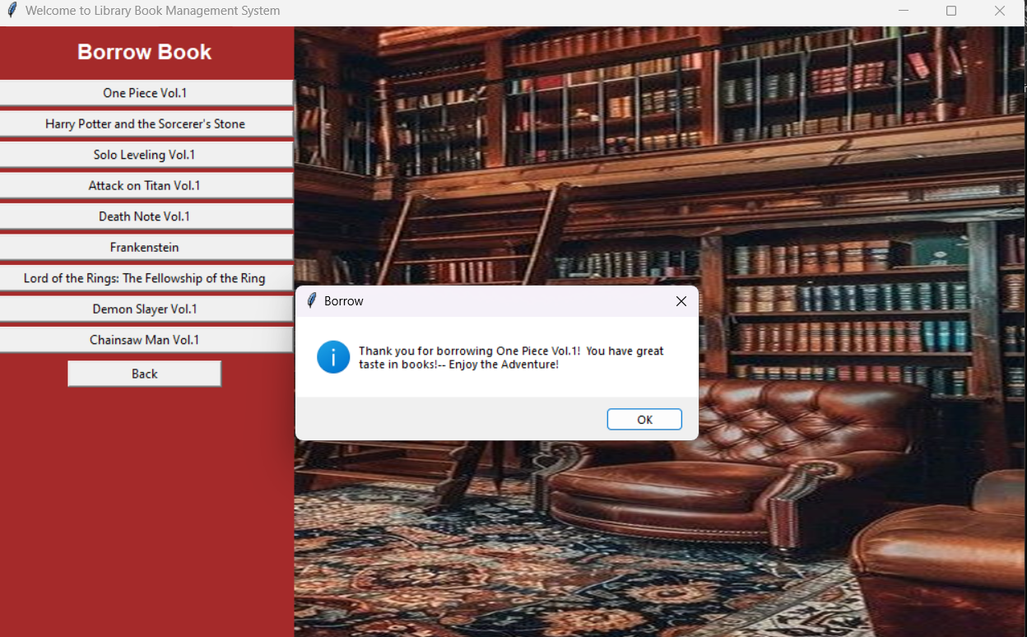

1. Return Book with Recommendation.

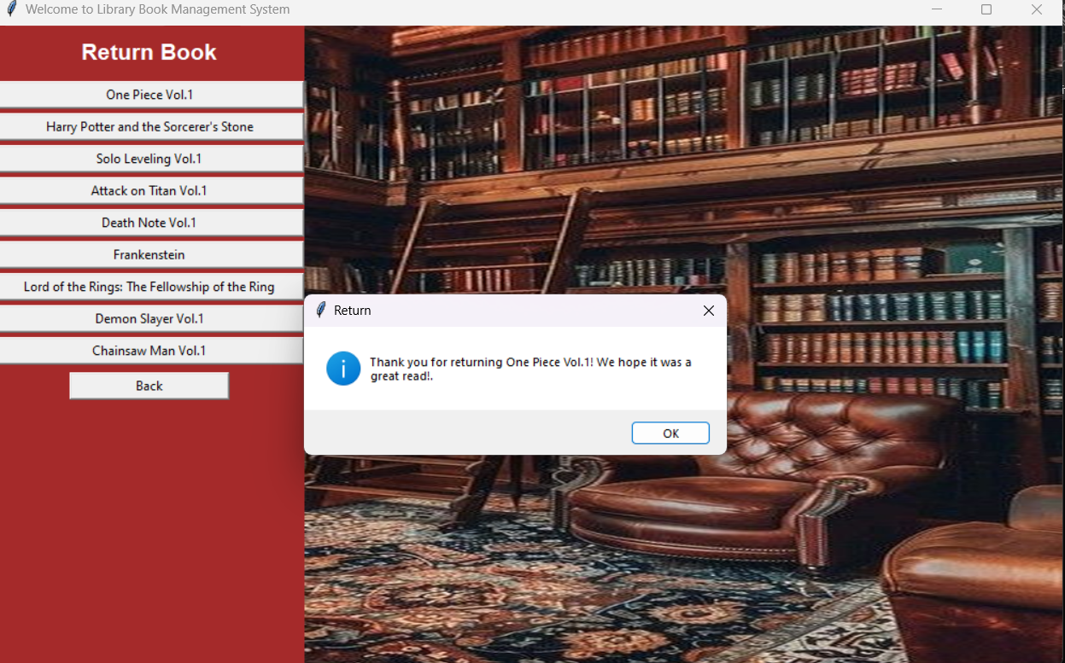

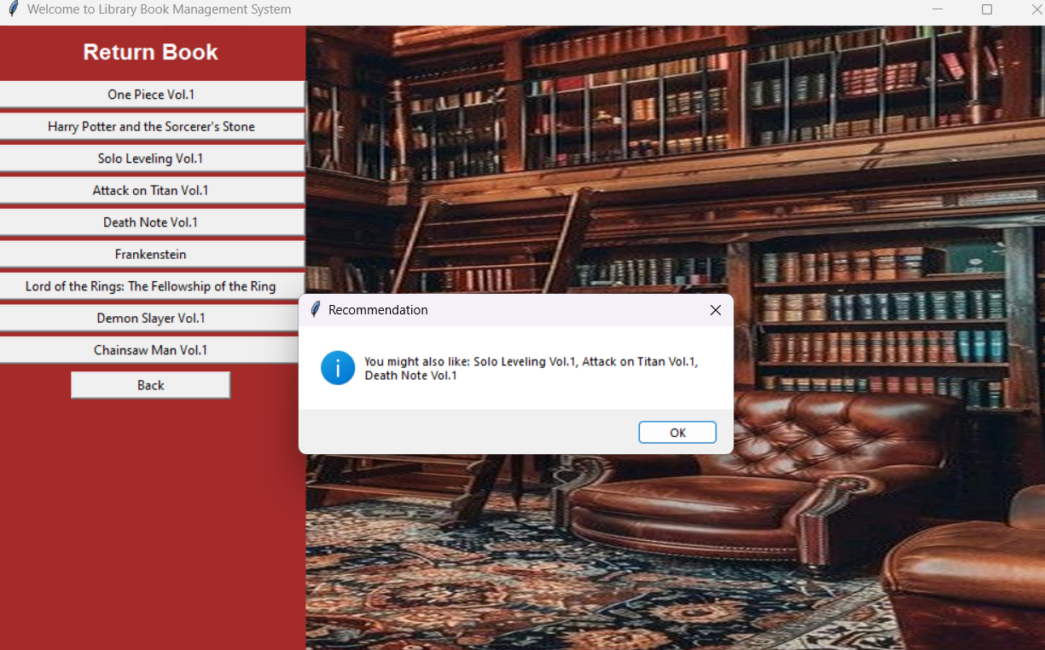

1. History

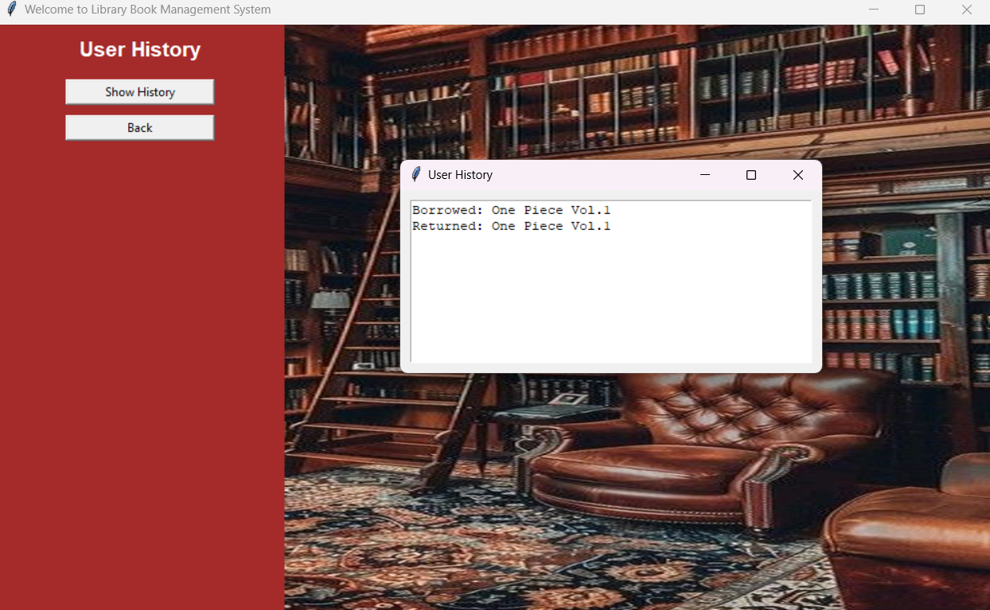

1. Exit (video)

